1. What is API Testing
API:
Before understanding API testing, we must understand API.
An API (Application Programming Interface) is a bridge that allows two software systems to communicate with each other.
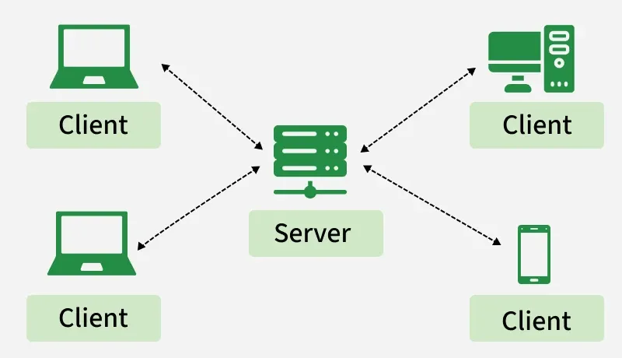
Example::
- You open a food delivery app.
- You select a restaurant and order food.
- The app sends your request to the restaurant’s system.
- The restaurant sends back the menu, price, and confirmation.
That communication between systems happens through an API.
The API is like a waiter in a restaurant:
- You (client) place the order
- The waiter (API) takes the request to the kitchen (server)
- The kitchen prepares the response
- The waiter brings the response back to you
You never interact with the kitchen directly; the API handles everything.

What is API Testing
API Testing is the process of verifying that APIs work correctly, reliably, securely, and efficiently.
Instead of testing the user interface, we test the backend communication between systems.
API testing checks:
- correct request format
- correct response
- proper status codes
- response time
- Security

Why API Testing is Important
API testing is critical today because:
- Modern applications are API-driven
- Microservices architecture depends heavily on APIs
- UI changes often, APIs stay stable
- Testing APIs is faster than UI testing
Companies like Netflix, Amazon, Uber, PayPal rely heavily on APIs.

What API Testers Verify
Area | What we verify
Functionality | Correct data returned
Reliability | Works under load
Security | No unauthorized access
Performance | Fast response
Error Handling | Correct failure messages

2. What Can You Do in API
APIs allow systems to exchange data and perform actions.
In practical terms, APIs allow you to perform CRUD operations.
CRUD stands for:
operation | Meaning
Create | Add new data
Read | Retrieve data
Update | Modify data
Delete | Remove data
Types of API Testing
Unit Testing
Testing individual components or functions of a program to ensure they work correctly.
Integration Testing
Testing how different modules or systems work together after being combined.
End-to-End Testing
Testing the complete application workflow from start to finish to ensure everything works together.
Performance Testing
Testing how fast, stable, and responsive the system is under different conditions.
Functional Testing
Testing whether the system works according to the specified requirements and expected behavior.
Security Testing
Testing the system to identify vulnerabilities and ensure data and resources are protected.
Load Testing
Testing how the system performs when many users or requests access it at the same time.
Penetration Testing
Simulating cyberattacks to find security weaknesses in the system.
Reliability Testing
Testing whether the system performs consistently and without failure over time.
Fuzz Testing
Testing the system by providing random or unexpected inputs to check for crashes or errors.

3. What Are Status Codes
When an API sends a response, it includes a status code that tells the client whether the request succeeded or failed.
These are called HTTP Status Codes.
They are 3-digit numbers.
Example:
200 OK
404 Not Found
500 Internal Server Error
These codes help developers quickly understand what happened.

200 – OK
The request was successful.

201 – Created
Used when a resource is successfully created.

204 – No Content
The request succeeded but no data is returned.

400 – Bad Request
The request was invalid.

401 – Unauthorized
User is not authenticated.

404 – Not Found
The requested resource does not exist.

4. What is HTTP
HTTP stands for:
HyperText Transfer Protocol
It is the communication protocol used by the web.
It defines how data is requested and transmitted between client and server.
When you open a website:
- Browser sends request
- Server processes it
- Server sends response
This communication uses HTTP.

HTTP Characteristics
HTTP is:
- Stateless-Each request is independent.The server does not remember previous requests
- Request-response based
- Text-based protocol

HTTP Methods

Method | Purpose
GET | Retrieve data
POST | Create data
PUT | Update data
PATCH | Partial update

5. What is HTTPS
HTTPS stands for:
HyperText Transfer Protocol Secure
It is the secure version of HTTP.
The difference is encryption.

HTTP vs HTTPS
Feature | HTTP | HTTPS
Security | Not secure | Secure
Encryption | No | Yes
Port | 80 | 443
Data Protection | None | Encrypted

Why HTTPS is Important
Without HTTPS:
- Data can be stolen
- Passwords can be intercepted
- Attackers can read communication
With HTTPS:
- Data is encrypted
- Secure connection
- Safe authentication

How HTTPS Works
- Client sends request
- Server sends SSL certificate
- Client verifies certificate
- Secure encrypted connection established
- Data exchanged safely

HTTP vs HTTPS
Feature | HTTP | HTTPS
Full Form | HyperText Transfer Protocol | HyperText Transfer Protocol Secure
Security | Not secure | Secure
Encryption | No encryption | Uses encryption
Data Protection | Data sent in plain text | Data is encrypted
Port Number | Port 80 | Port 443
Data Safety | Data can be intercepted by hackers | Data cannot be easily intercepted
URL Format | http:// | https://
Website Trust | Less trusted by browsers | More trusted by browsers
Usage | Informational websites | Banking, e-commerce, login systems
Performance | Slightly faster (no encryption) | Slightly slower due to encryption but safer

